SPRINT-1

Installing Prerequisites

| Team ID | PNT2022TMID15311 |
| --- | --- |
| Project Title | DemandEst-AI Powered Food Demand Forecaster |

All team members installed the pre-requisites.

TEAM LEADER: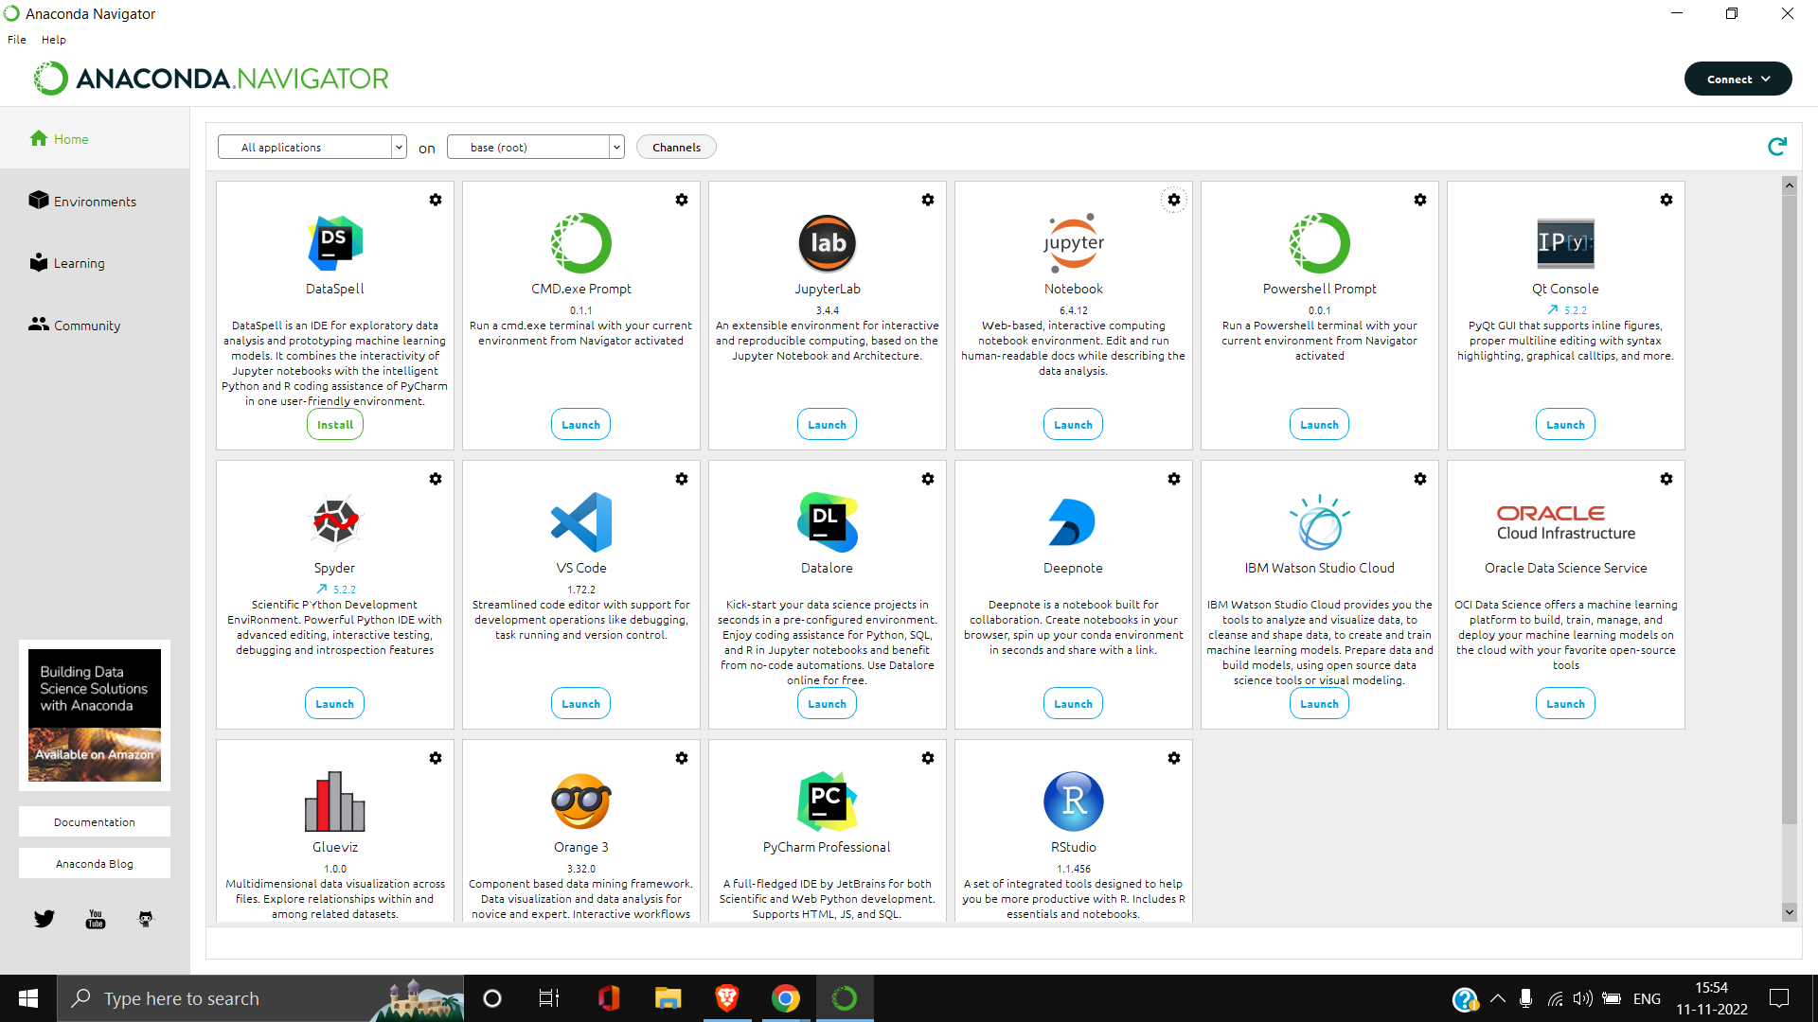

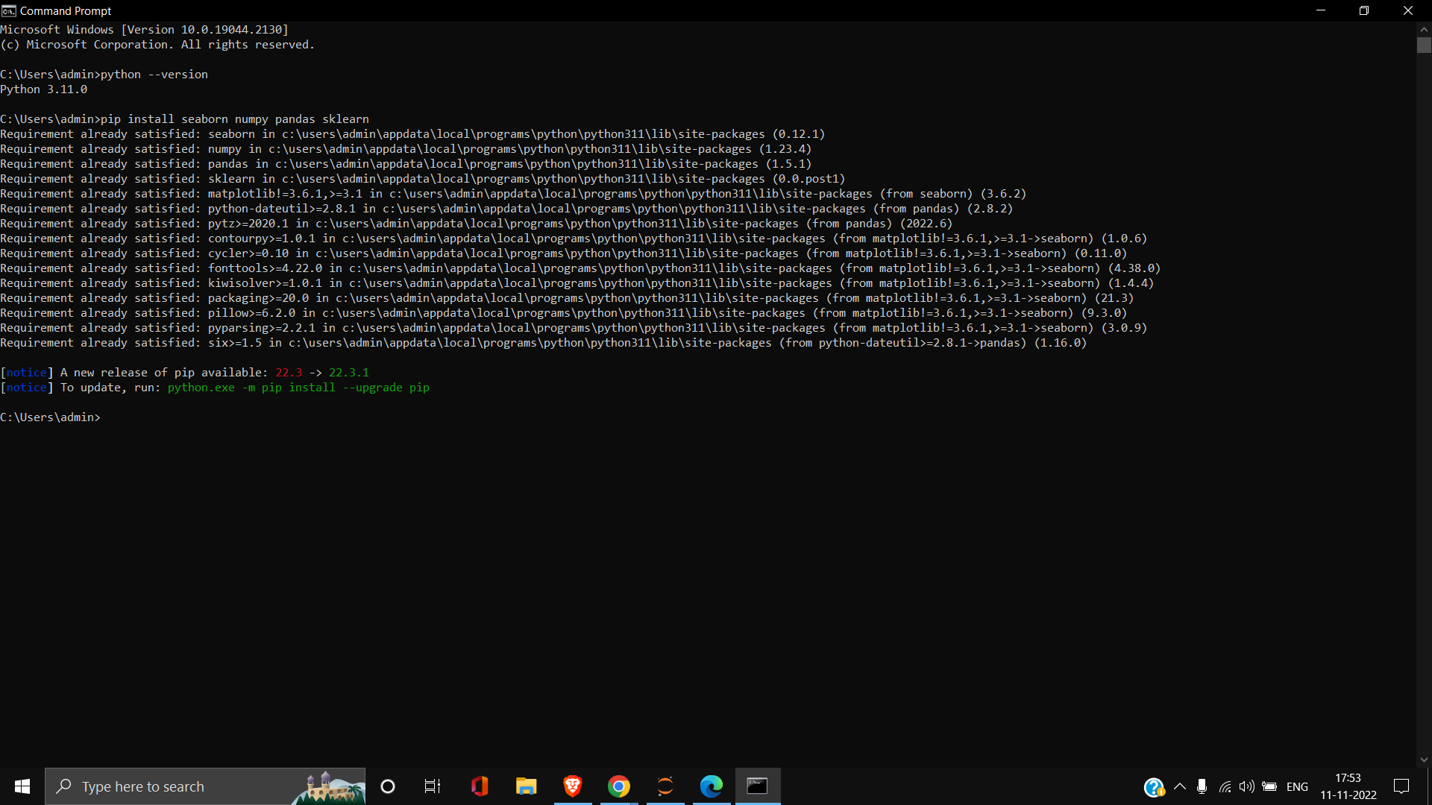

TEAM MEMBER 1





TEAM MEMBER 2





TEAM MEMBER 3



